Clatsop Cruise Hosts Blue Binder

Host Reference Guide

TABLE OF CONTENTS
- ✦ Welcome
- ❖ Host Locations
- ✧ Getting Around
- ✹ Emergency Information
- ⚓ Cruise Ship Schedule 2026
- ✪ Tourist Attractions
- ⧈ Banks & ATMs
- ≋ Wi‑Fi
- ⌂ Restrooms
- ✤ Shopping Suggestions
- ✱ Restaurant Suggestions
- ⌖ Maps
- ❘❙❘ CCH Policies for Hosts

✦ WELCOME


Your Guide to Hosting With Heart

❖ HOST LOCATIONS

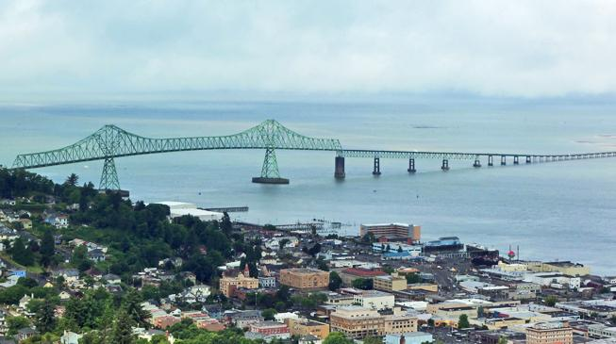

Where to Find Our Hosts

✧ GETTING AROUND



Transportation, Routes & Local Tips

✹ EMERGENCY INFORMATION



Safety First, Always

⚓ CRUISE SHIP SCHEDULE 2026

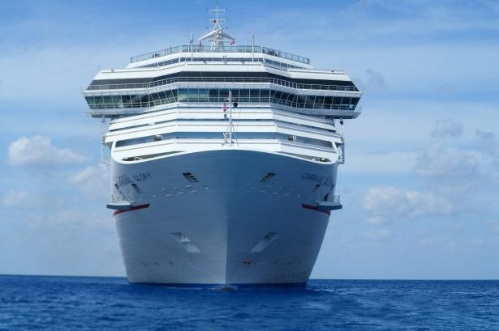

Arrivals, Departures & Port Details

✪ TOURIST ATTRACTIONS



What Visitors Love Most

⧈ BANKS & ATMs



Financial Services Nearby

⌁≋ WI‑FI



Stay Connected

⌂ RESTROOMS



Facilities & Locations

✤ SHOPPING SUGGESTIONS



Local Finds & Visitor Favorites

✱ RESTAURANT SUGGESTIONS



Where to Eat & What to Try

⌖ MAPS



Orientation & Wayfinding

❘❙❘ CCH POLICIES FOR HOSTS



Standards, Expectations & Best Practices

